CYBERSECURITY INTERNSHIP
Organization name: Elevate labs

Student Name: Radhika Lakshmi. Teeramdasu
University: Aditya University
Domain: Cybersecurity
Duration: 1st January 2026 to 30th April 2026

TASK-5: Malware Types & Behavior Analysis (Basic)
Malware (Malicious Software) refers to any program or code intentionally designed to cause harm to systems, networks, or users. Malware affects confidentiality, integrity, and availability of data and systems. The most common malware types include virus, worm, trojan, and ransomware, each having different characteristics and behaviors.

Virus:
A virus is a malicious program that attaches itself to legitimate files or programs. It requires user action, such as opening an infected file, to execute and spread. Once activated, a virus can corrupt files, slow down system performance, or destroy data. Viruses usually spread through infected email attachments, removable media like USB drives, or pirated software.
Worm:
A worm is a standalone malware that does not require user interaction to spread. Worms exploit network vulnerabilities and automatically propagate across systems. Because of their self-replicating nature, worms consume network bandwidth and system resources rapidly, often causing network congestion or system crashes.
Trojan Horse:
A trojan (Trojan Horse) disguises itself as a legitimate or useful application to trick users into installing it. Unlike viruses and worms, trojans do not self-replicate. Once installed, a trojan can create backdoors, steal sensitive information, log keystrokes, or give attackers remote access to the system.
Ransomware:
Ransomware is one of the most dangerous forms of malware. It encrypts user data or locks the system and demands a ransom payment, usually in cryptocurrency, to restore access. Ransomware attacks can cause massive financial and operational damage to individuals, organizations, and governments.

- Upload known malware samples (hashes) to VirusTotal:
Directly uploading live malware files is unsafe and unethical. Therefore, analysis is done using file hashes (MD5, SHA-1, or SHA-256). A hash uniquely identifies a file without exposing the actual malware.
VirusTotal is a free online malware analysis service owned by Google. It scans files, URLs, IPs, and hashes using multiple antivirus engines. By submitting a malware hash, we can view detection results, behavior reports, and threat intelligence without executing the malware locally.
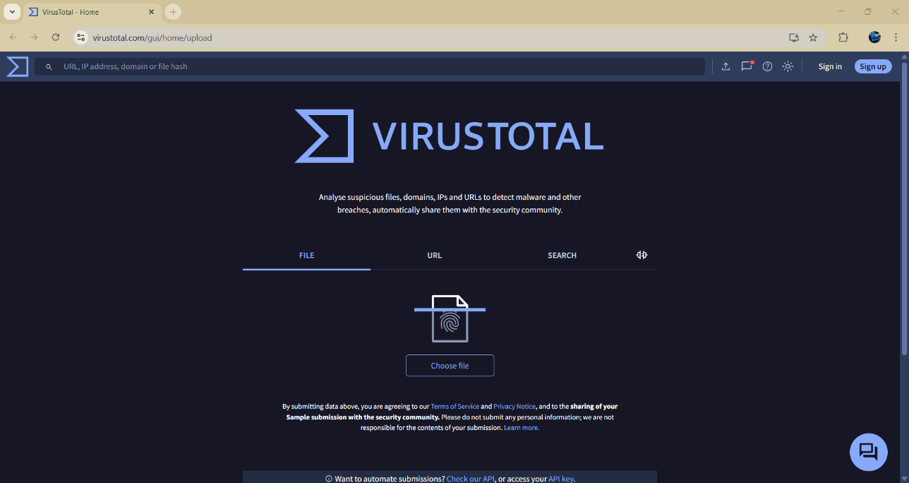

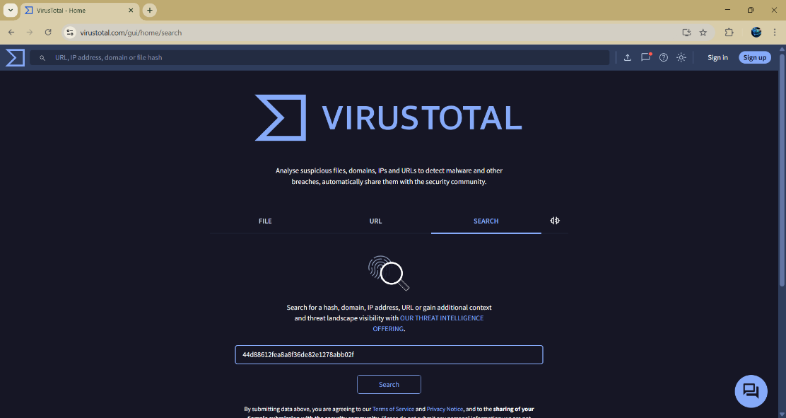

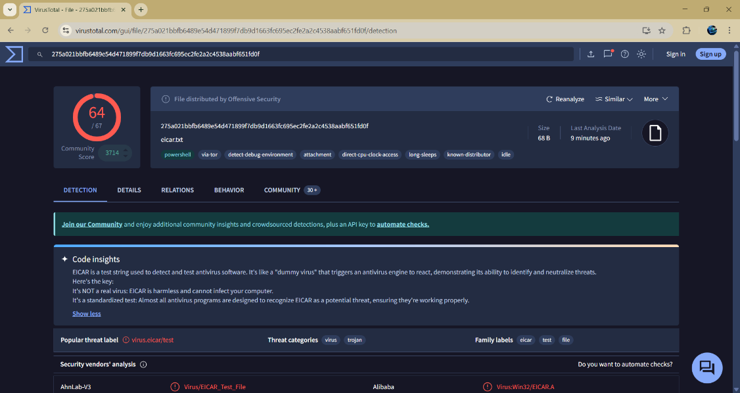
The taken sample hash - 44d88612fea8a8f36de82e1278abb02f

Detection ratio: 64 out of 67
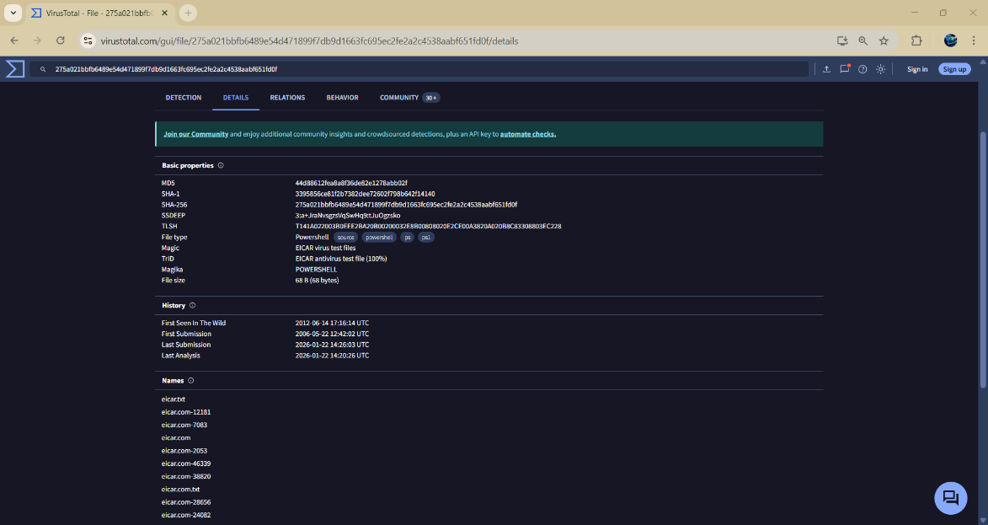

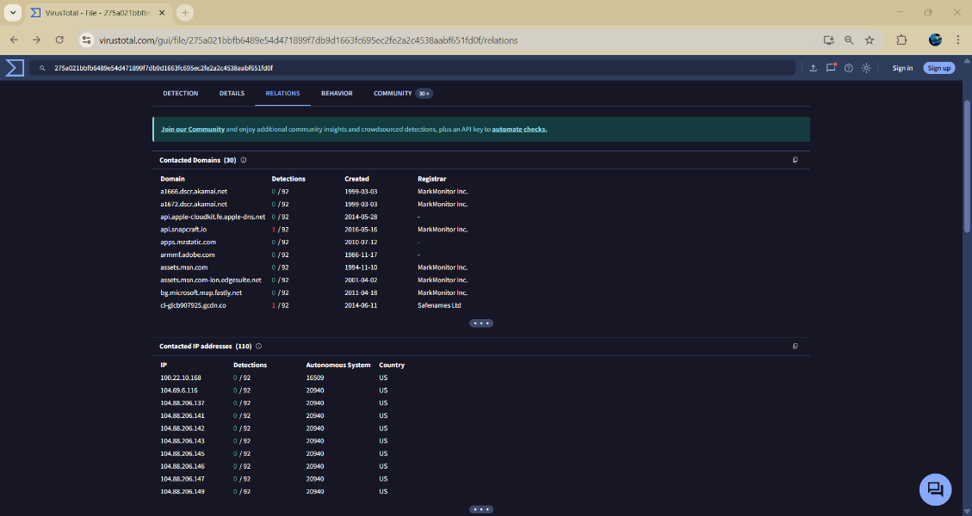

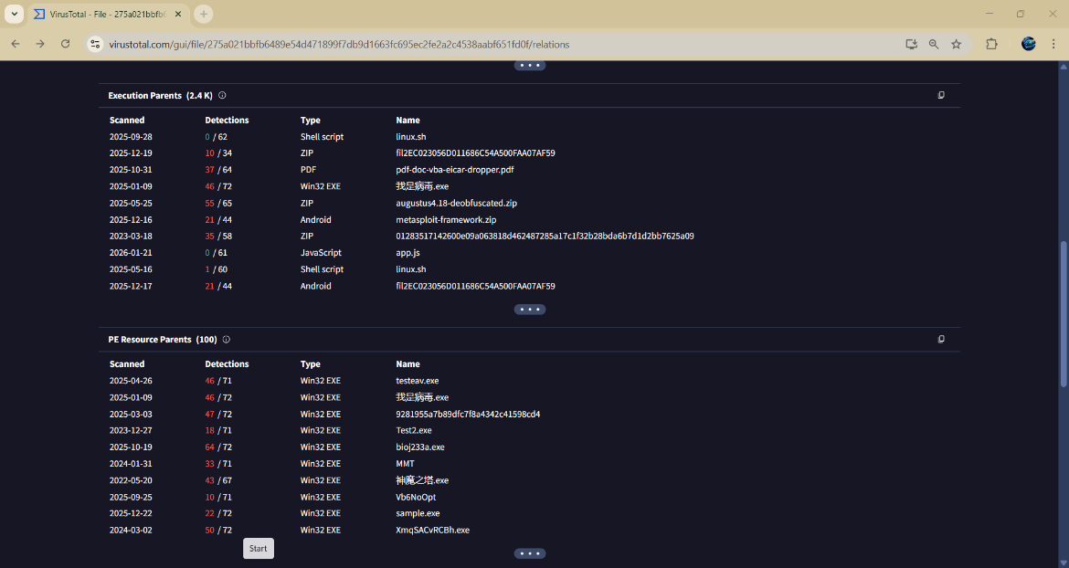

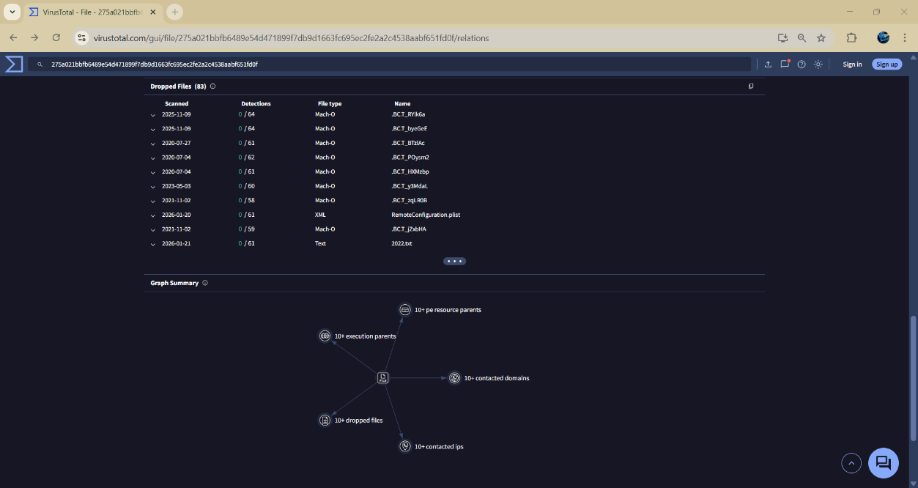

- Analyze detection reports:
Malware name: DOS.EiracA.Trojan
Threat category: EICAR test file
Behavior analysis: Malware trojan evader
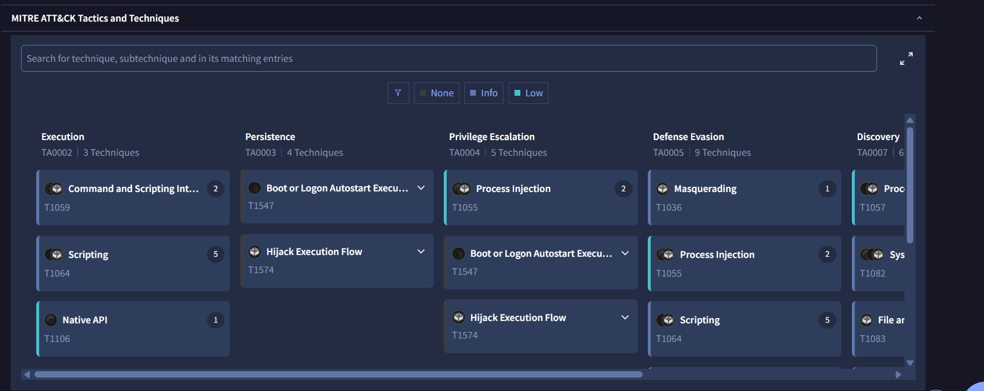
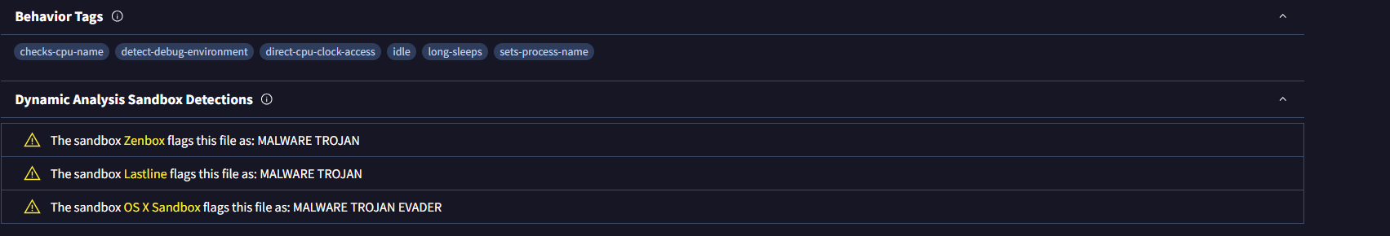
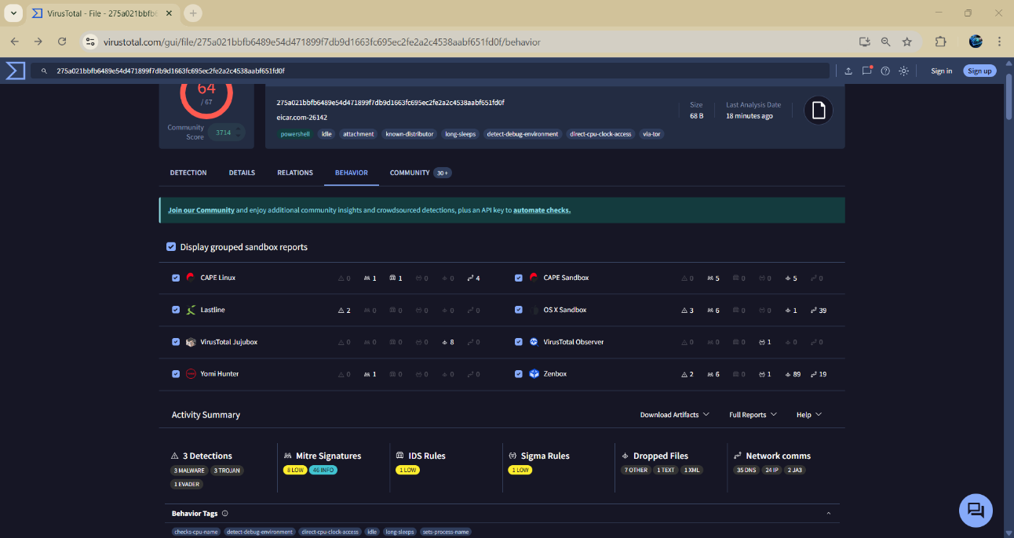
Network activity: 32 DNS, 24 IP and many more are identified while executing this file.
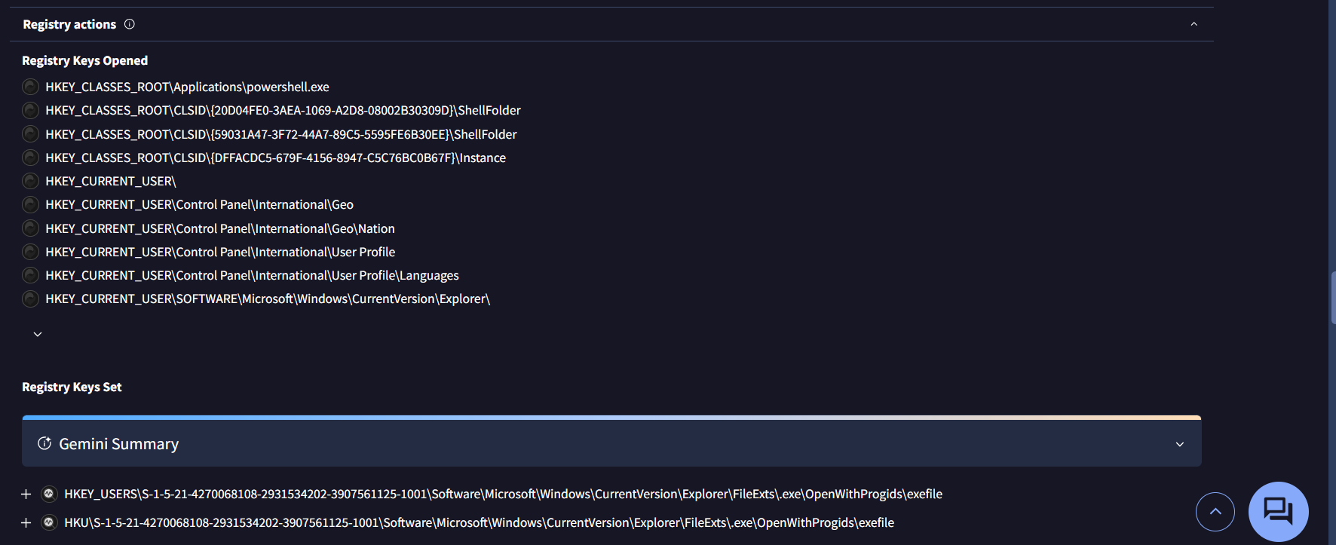
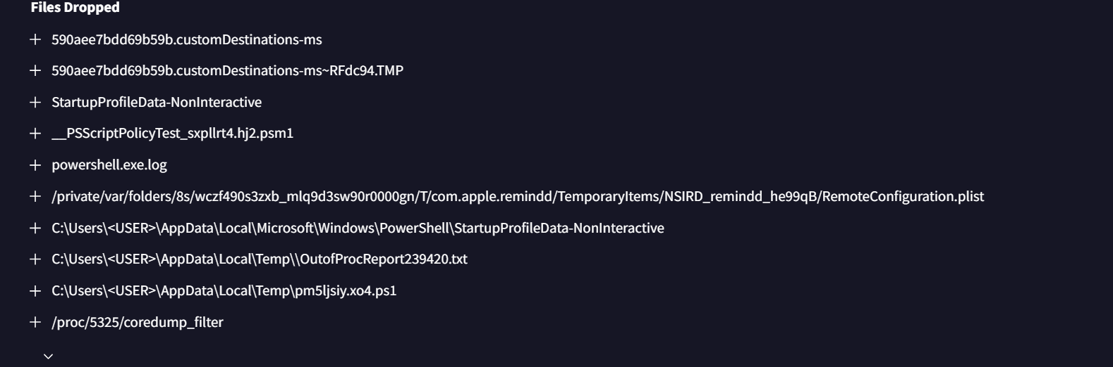
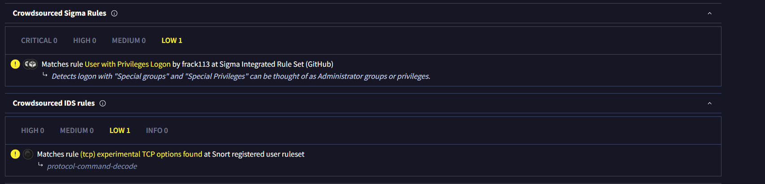
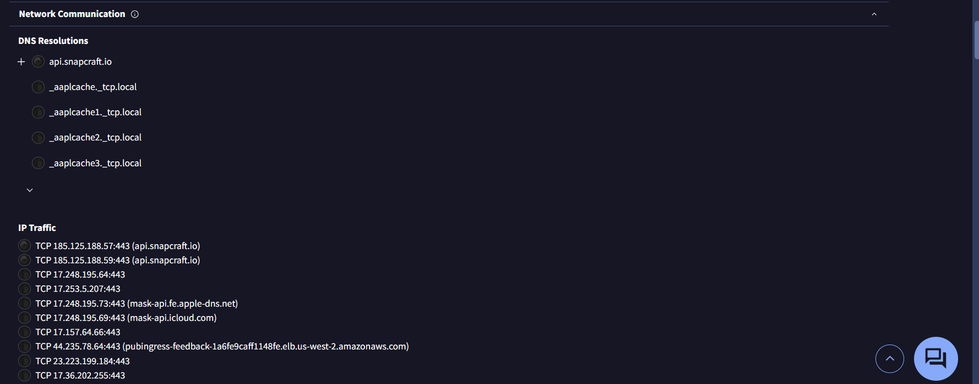
Registry findings
- Observe behavior indicators:
The observed behavior indicators show that the malware attempts to modify system files and registry entries, which suggests persistence mechanisms. By making registry changes, the malware ensures it can automatically execute after system reboot. The malware also demonstrates file system activity, such as creating or dropping additional files in system directories. This behavior indicates that the malware may install secondary payloads or supporting components required for its operation.
These are the major behavior analysis observed after analysing that hash in the irustotal application.

- Malware lifecycle:
Creation/Development:
Malware is designed by attackers to achieve specific goals, such as stealing data, disrupting systems, or encrypting files. Techniques like obfuscation, packing, and polymorphism help it avoid detection.
Delivery/Distribution:
Malware is delivered to the target through phishing emails, malicious downloads, infected USBs, fake software updates, or exploiting system vulnerabilities.
Exploitation:
Once delivered, malware takes advantage of system flaws or user actions to execute its code.
Installation/Persistence:
Malware installs itself and ensures it stays on the system, often hiding from the user or antivirus software, using methods like registry modification, services, or rootkits.
Command & Control (C2):
Some malware connects to remote servers controlled by attackers to receive commands, exfiltrate data, or update itself.
Actions on Objectives:
Malware carries out its intended purpose, such as stealing sensitive information, encrypting files (ransomware), disrupting systems, or spreading to other devices.
Detection/Removal:
Eventually, malware may be detected and removed by antivirus tools or system scans, though some damage, like stolen data or system changes, may remain.

- How malware spreads:
Malware spreads using various techniques depending on its type.
Common spreading methods include:
- Phishing emails with malicious attachments or links
- Drive-by downloads from compromised websites
- Exploiting unpatched system vulnerabilities
- Infected USB drives or external storage
- Pirated or cracked software downloads
- Network-based spreading using open ports and services
Modern malware often uses social engineering to trick users rather than relying only on technical vulnerabilities.

- Prevention methods:
Preventing malware requires a combination of technical controls and user awareness.
Key prevention methods include:
- Installing and updating antivirus and anti-malware software
- Regularly patching operating systems and applications
- Avoiding suspicious links and unknown email attachments
- Using strong passwords and multi-factor authentication
- Disabling macros in documents from unknown sources
- Regular data backups to mitigate ransomware attacks
- Using firewalls and intrusion detection systems
User education plays a vital role in preventing malware infections.

- Summary:
Malware analysis using VirusTotal provides valuable insights into malware classification, detection rate, and behavior. By understanding different malware types, their lifecycle, and spreading methods, security professionals can effectively detect and prevent attacks. Behavior-based analysis complements signature-based detection, making threat identification more accurate. This task builds strong foundational knowledge in malware awareness and detection.

